nano@illinois
Research Experiences for Teachers (RET)
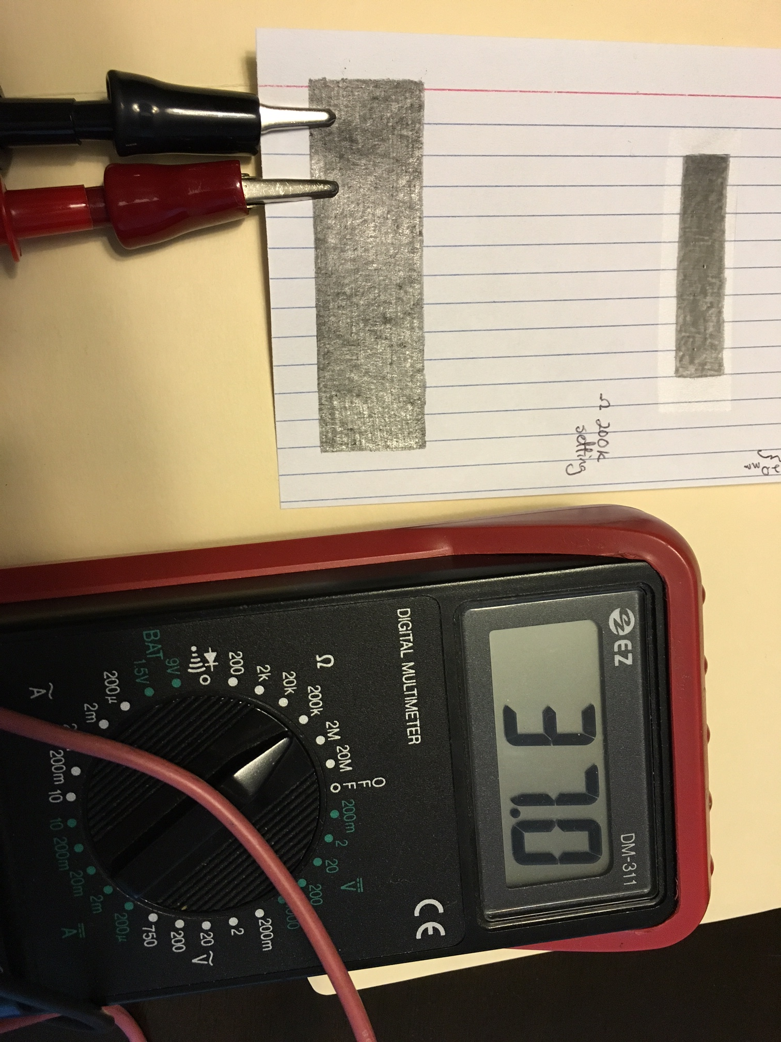
Exploring Conductivity and Thickness with Graphite
Tom Gelsthorpe
Champaign Central High School
2015-2016

Description:
Students will use 4 x 6 notecards and scissors to create masks to place over other notecards to lay down layers of graphite. By measuring the length of the graphite in a mechanical pencil before laying down the layers of graphite and then measuring the length afterward, the volume of the graphite used can be determined based on the diameter of the graphite insert. By measuring the area on the bottom notecard over which this graphite was applied and the volume of graphite from the insert, one can determine the thickness of the applied layer of graphite.

Students can make a number of different applications on various notecards to determine whether any relationship exists between the thickness of the graphite and its electrical properties. Within a given application of graphite, students can determine the relationship between the distance and resistance.
This could serve as an application of dimensional analysis, as well as a means of distinguishing between bulk properties of materials and the properties of their components

Learning objectives:

Students will determine:
-the thickness of a layer of graphite
-the number of layers of graphene in a sample of graphite on table
-the relationship between the thickness of graphite on paper and resistance.

Prerequisite knowledge/skills:
Students need to know how to measure accurately using a ruler; determine the volume of a cylinder; use conversions; and use scientific notation.

Duration: 2 50-minute class periods

Target grade level(s): 10th/11th

Target subject(s): Chemistry; Physics; Physical Science

Alignment with Next Generation Science Standards:

HS-PS1-3 Matter and Its Interactions

Plan and conduct an investigation to gather evidence to compare the structure of substances at the bulk scale to infer the strength of electrical forces between particles.

Disciplinary Core Idea
PS1.A: Structure and Properties of Matter
- The structure and interactions of matter at the bulk scale are determined by electrical forces within and between atoms.

Crosscutting Concepts
Patterns
- Different patterns may be observed at each of the scales at which a system is studied and can provide evidence for causality in explanations of phenomena.

Practices
Plan and conduct an investigation individually and collaboratively to produce data to serve as the basis for evidence, and in the design: decide on types, how much, and accuracy of data needed to produce reliable measurements and consider limitations on the precision of the data (e.g., number of trials, cost, risk, time), and refine the design accordingly.

The bulk material of graphite will be explored as an analogue for graphene. In my research project, I was making graphene in a CVD oven, then applying coatings to try to control the amount of doping on the graphene, then applying an electrical field to determine the effect of the coating.
Parts of the process that I intend to simulate in this module include: making a mask to control the shape and size of the graphene area, determining the number of carbon layers, measuring electrical properties of carbon
Background:
Graphite, the material found in pencils, consists of many layers of carbon arranged in hexagons. Graphene is a single sheet of hexagonal carbons; the distance between these layers is about 3.4 angstroms.

Preparation time: For teacher: Gathering materials would take 15 minutes.

Preparation notes for materials and chemicals:
No special precautions would need to be taken, as all materials are typical office supplies, with the exception of the multimeter. Students should observe typical precautions regarding batteries and scissors.
- Ohmmeters can provide a more quantitative measurement of electrical properties (resistance); however, this can be problematic at times
- One solution to this is to apply the graphite near the edge of the notecard, so that the clips can be attached and reach the graphite

Safety:
Scissors may present a cutting hazard; the multimeter, when set to measure resistance, should present no issues, but there could be a slight shock hazard if mishandled. If improperly stored, 9-V batteries could pose a fire hazard.

Waste disposal:
All paper/graphite/tape wastes can be disposed of in the regular trash stream. 9-V batteries should not be thrown away with regular trash, so check with your city or town for the best way to dispose of them, but cover the posts with tape until ready to be disposed of.

Materials/supplies/equipment needed with example source listed/pricing/CAS # and contact information

Mechanical pencils with 0.7 mm and 0.9 mm graphite thickness (On amazon.com: BIC Pencil Xtra Sparkle (colorful barrels), Medium Point (0.7 mm), 24-Count, by BIC; $7.79)

Metric rulers (On amazon.com; Westcott Finger Grip Ruler, Smoke Plastic, Inches and Metric, 12-inch (00402), by Westcott; $2.00)

4 x 6 notecards (On amazon.com; TOPS Index Cards, 4 x 6-Inches, White, Ruled, 100 Cards/Pack, Box of 30 Packs (62526W), by Tops; $29.58)

Multimeter (On amazon.com; Volmate Digital LCD Voltmeter Ammeter Ohmmeter Multimeter Volt AC DC Tester Meter, by Volmate; $8.68)

Scissors (On amazon.com; IIT 90450 5 Piece Stainless Scissors Set, by IIT; $9.19)

Green LEDs (On amazon.com; microtivity IL133 5 mm Diffused Pure Green LED w/Resistors (Pack of 30), by microtivity; $5.39)

9-V Batteries (On amazon.com; AmazonBasics 9 Volt Everyday Alkaline Batteries (8-pack), by AmazonBasics; $9.49)

Wires with alligator clips (On amazon.com; Elenco TL-6 Alligator Lead Set, 10-Piece, 14 inches, by Elenco; $2.55)

Scotch Magic Tape (On amazon.com; Scotch Magic Tape 3105, ¾ x 300 Inches, Pack of 3, by Scotch; $3.00)
Procedure/activity:

Day 1

Students should work in pairs that make masks that have one dimension in common. For Day 1, the following materials will be needed: mechanical pencils, metric rulers, 4 x 6 notecards, and scissors. (Calculators will also be needed.)

Introduction
- The teacher will briefly introduce the activity by talking about graphite and graphene, including applications of graphene. The structures of each should be shown. Students could also read the articles about the history of graphene and why they should care about it as a primer for the activity.

Making the Mask
- A 4” x 6” notecard is folded in half.
- Mask length is measured using a ruler (<4.5 cm for the practical purposes) while the width is determined by spacing between the lines that are cut on.
Graphite Transfer
- The mask is placed on top of another notecard sideways, so that it is perpendicular to the lines on the notecard beneath it for ease of measurement.
- The graphite is removed from the mechanical pencil and its length is measured to the nearest tenth of a millimeter, then returned to the pencil.
- Using the mask as a guide, the edges are first traced in, then the remainder of the area inside the mask is covered in graphite, with care taken to not break the graphite; placing the graphite near the bottom will make later testing easier.
- After the graphite has been applied, the dimensions it was applied over and its length must be measured again.
- This should be repeated using the same mask with the intentional application of different thicknesses. It can also be repeated using different masks with some dimension in common.
Thickness Determination
- By treating the graphite from the pencil as a cylinder, the volume of graphite used can be easily calculated by V = πr²Δl, with Δl being the difference between the lengths (r = d/2).
- Measuring the dimensions of the area the graphite is spread over and assuming a uniform layer allows for the thickness to be determined by V/A.
- On the graphene-based devices, the thickness was determined by Raman spectroscopy. Visual inspection allows for relative thickness to be determined as well. (Darker areas indicate thicker graphite deposits.)
- By using the conversion factor 1 mm = 1 x 10⁷ angstroms and the spacing between the layers of graphite being 3.4 angstroms, the number of layers in the graphite on the paper can be determined.
- Due to uncertainties in the measurements, this will only really be able to be determined to one significant figure. (A typical thickness might be 5 x 10⁻⁴ mm, meaning there would be about ~1000 layers of graphene present)
Day 2
Device Measurements
- One way to test the electrical properties (such as the relationship between distance and conductivity and thickness and conductivity) is to use a 9 V battery, alligator clips, and LEDs.
  - The red clip should be attached to the positive terminal of the battery on one end and the longer leg of the LED on the other end.
  - The black clip should be attached to the negative terminal of the battery on one end and the graphite on the other end.
  - Green LEDs seem to work best because red LEDs are very dim and can stop emitting light at greater distances, while blue LEDs are too bright across all distances to be useful all of the time.
- Ohmmeters can provide a more quantitative measurement of electrical properties (resistance); however, this can be problematic at times
  - One solution to this is to apply the graphite near the edge of the notecard, so that the clips can be attached and reach the graphite.
  - The spacing of the clips can easily be aligned with the lines on the notecard, which is why the mask was applied perpendicularly on day 1.
  - In general, students should wait 3 seconds before looking at the values to give the ohmmeter time to stabilize; a few values should be recorded, but strict mathematical relationships will be elusive.
  - A sample set of values using a graphite layer that is 7 x 10⁻⁴ mm thick with the ohmmeter on 200K Ω are: 7.0 with the clips 2 lines (12.8 mm) apart, 10.6 with the clips 4 lines apart, and 25.0 with the clips 6 lines apart.
Reporting and sharing
- Students should determine the relationship between conductance and distance using their graphite. They should also use their values from the previous day to determine the relationship between the thickness of the graphite layer and how well it conducts.

- Each group should report their results for classroom comparison.

Extended Module Ideas
- After students have determined at least rough electrical properties of the “devices”, here are suggested extensions:
  - Student contest to make the longest path that can still light up an LED (and can defend the length of the path); reinforces distance conductivity relationship .
  - Alternatively, challenge students to create a graphite application that gives a particular resistance.
- Switches can be built using a piece of tape beneath a small section of the graphite. This is an alternate method for creating open and closed circuits as opposed to erasing a portion of the line. Students will need to be sure to apply graphite in a thick layer at the junctions between tape and paper. Other means of making paper/graphite switches can be found on youtube. (See resources section)
- Students can research further materials’ electrical properties (such as metals) as well as Ohm’s Law.
- Students can also test devices where tape is used on top of the notecard section before graphite is applied. Prior research suggests this improves consistency of graphite application. This would be useful for small masks or long lines of graphite.

Presentation talking points:

Slide 1: Comparison of structures

Slide 2: Why graphene could be important

Slide 3: Goals with pictures

Links to the research articles and other resources:

Paper Circuit! on youtube: https://www.youtube.com/watch?v=BwKQ9Idq9FM (can be stopped at 2:50)

Paper Circuits – GSF2014 on youtube: https://www.youtube.com/watch?v=nD4l8NQ8x_M (shows another way to create a switch)

The Story of Graphene at the University of Manchester: http://www.graphene.manchester.ac.uk/explore/the-story-of-graphene/

Why You, Non-Nerd, Should Get Excited about Graphene:
https://www.yahoo.com/tech/why-you-non-nerd-should-get-excited-about-graphene-87271772974.html

Research on the devices the activity is modeled after:

Hinnefeld, J. H.; Xu, R.; Rogers, S.; Pandya, S.; Shim, M.; Martin, L. W.; Mason, N. arXiv preprint arXiv:1506.07138, 2015.

Tuinstra, F.; Koenig, J. L. Raman spectrum of graphite. The Journal of Chemical Physics, 1970, 53(3), 1126-1130.

Woolf, L.; Streckert, H. Graphite pencil line for exploring resistance. The Physics Teacher, 1996, 34, 440-441.

Derman, S.; Goykadosh, A. A pencil-and-tape electricity experiment. The Physics Teacher, 1999, 37, 400-402.

Acknowledgements
I would like to thank J. Henry Hinnefeld and Dr. Nadya Mason for their guidance and advice; Wyatt Behn, Anh Dang, and Stephen Gill for their assistance in device fabrication; Dr. Irfan Ahmad and Carrie Kouadio, and technical staff at the Micro and Nanotechnology Lab, and Center for Nanoscale Science and Technology support for their roles in this program; and lastly, my wife, Erin, whose support made my participation possible.

Financial support was provided by the National Science Foundation under grant #NSF EEC 14-07194 RET, as part of the nano@illinois project, through the University of Illinois Center for Nanoscale Science and Technology and the Micro and Nanotechnology Lab at the University of Illinois at Urbana-Champaign.

This work, which includes teacher and student resources, is licensed under a Creative Commons Attribution-Noncommercial-Share Alike 3.0 Unported License. To view a copy of this license, visit: http://creativecommons.org/licenses/by-nc-sa/3.0/. To attribute this work, please use [“J. Doe. Title (Date).”]
The nano@illinois Research Experience for Teachers (RET) at the University of Illinois at Urbana-Champaign (from 2014-2017) exposes a diverse set of in-service and pre-service science, technology, engineering, and mathematics (STEM) teachers and community college faculty from across the nation to cutting-edge research in nanotechnology. The RET focuses on recruiting underrepresented minority populations (focused on ethnicity, geography, disability, and veteran status) including women and will target teachers from high-need areas, including inner city, rural, low-income, and those with significant URM students. Participants conduct research over 6 weeks in world-class labs with 4 follow-up sessions during the school year.
Teacher professional development opportunities includes teacher-focused lectures, mentoring, networking, poster sessions, ethics seminars, hands-on modules, STEM education issues, career choices, and resources for implementing a nano lab and curriculum. Teachers will develop modules to be disseminated widely and present their results. High-quality follow-up sessions and evaluation will be infused.

The nano@illinois Research Experiences for Teachers (RET) is managed by the University of Illinois Center for Nanoscale Science Technology.

Center for Nanoscale Science and Technology
208 N. Wright, MC-249
Urbana, Illinois 61801
217-244-1353
nanotechnology@illinois.edu
www.nano.illinois.edu

